Chapter 2

PURPOSE AND DESCRIPTION

Objectives of the System

The main objective is to create a web-based application, where individuals especially the newbies in programming can approach a person or a teacher who has better knowledge in a certain topic that he/she wants to explore/learn through Web conferencing, Live code editor, and Chat-box. It can also help skilled individuals in their free time to earn extra income.

Especially, it aims to:

1. Appreciate the Basic Programming Topic;

2. User-friendly GUI;

3. Provide students a new and enjoyable way of learning online.

4. Improves the students or persons basic programming skills and;

5. Make the way of teaching more fun and interactive with the teacher and student;

Scope and Limitation

Teachers can earn money while they are in their home using the extra time they have. Provide better-quality learning to all the students online who take up programming-related courses through live one on one style of teaching.

1. Manage the following:

1.1 Users

2. Process the following:

2.1 Register Users

2.2 Authenticate Users.

3. Provide the following for the tutorial:

3.1 IDE

3.2 Chat box support

4. Compute payment and Commission

5. Plot schedule for tutorial

6. Reserve schedule for tutorial

7. Navigate webcam or microphone

8. Provide topics for the tutorial

8.1 Basic Syntax

8.2 Data Types

8.3 Variables

8.4 Keywords

8.5 Basic Operations

8.6 Loops

8.7 Numbers

8.8 Characters

8.9 Arrays

8.10 Strings

8.11 Functions

9. Send email for notification

3. Generate the following:

3.1 Class Schedule

3.2 Payout Receipt

3.2 Rating

However, the system is not capable of the following:

1. Accept payout online
2. IDE that supports Windows
3. Connections of more than two (2) students

Significance of the Study

The findings on this study aims to determine the online learner programming problem issues or disadvantages and provide a solution that will beneficial to the users on researchers’ system.

This study will be helpful to the following:

Users. The research will help someone who wants to learn programming in a straightforward, precise, and pleasurable way.

Students. The study will provide a system to the students that having problems with their code that they want to fix without waiting. It will help them to easily understand and get the solution to their programming-related problems in no time and with less hassle.

Teachers. It will help the teacher who has free time that wants to earn extra income and also improve their mental and logic in teaching. In addition, it also makes them feel happy because their teaching helps a lot of students.

Academic Institution. It will help them to lessen their burden in making the student understand their lessons in regards to programming courses.

Researchers. This study will give a big help to future researchers on how to give alternate ways on helping the students who is struggling with their programming course they take up.

RESEARCH METHODOLOGY

Research Map

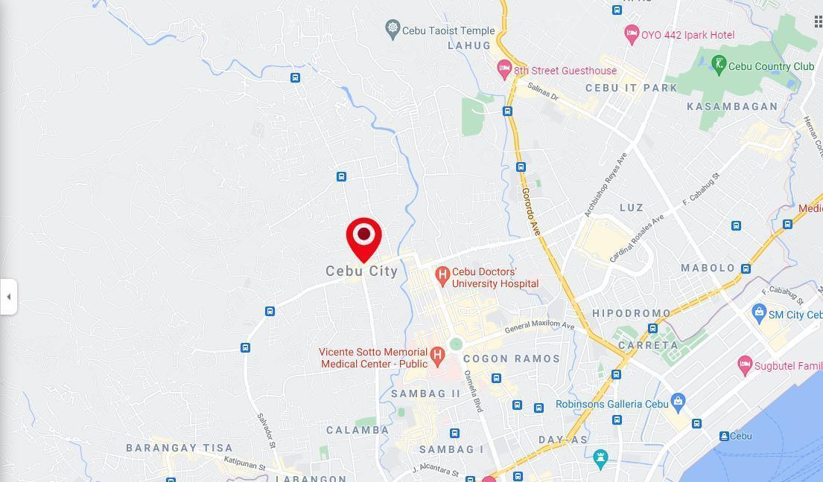

Figure 1: Map of Cebu City

Sources of Data

In order to develop the system, the researchers decided to gather a variety of information from different sources such as;

Questionnaires. To the available 20 participants that are into Information Technology or to a person who wants to learn programming that are living on the same area using Google Forms. They are relevant to researchers’ study because they are into or wanted to learn programming.

Ocular Observation. The observation is essential because they were able to determine the conflict and find a further solution on how to learn programming as easy as possible by developing the researchers’ system.

Internet. The researcher gathered some information and books online.

Published and Unpublished Books. By getting some sources, this may help them create and improve the system development.

Methods and Techniques

To make their system reliable and sustainable, researchers choose:

Agile Software Development. It enhances the capability and improvement of researchers’ system Each of the respondent’s answer or suggestions and users’ feedback will be analyze and applied it to make improvements and meet the users' exp expectation on researchers’ system. Researchers utilize this to make the system more reliable and immediately adapt changes in the system such as Designs, Program flow and Functionality.

Design Technique and Object-Oriented Analysis. The researchers are used to employ and to create a model of the system’s functional requirements that is independent of implementation constraints. The researchers will apply the implementation constrains to the conceptual model produced in object-oriented paralysis.

Models

The system would apply the Unified Modeling Language (UML) diagrams or representation and notation to exhibit the analysis and corresponding models. Researchers use UML to construct and visualize the processes of the system. It also describes and illustrates the structure designs or architectures of the system, and also exhibit the configuration of the system.

Class Diagram. The researchers, would also use this type of diagram to organize, give exact and direct insight into their systems. It focuses on the entities that need and required to develop their system;

Use Case. The researchers use this to easily see a graphical representation of a user's possible interactions with a system.

Gantt Chart. The researchers are aware that they have a finite amount of time to finish the system that is why the researchers decided to use the Gantt chart so the researchers can track their phasing, goals, and sub-task on every plan and schedule that we're going to make when developing this system.

Tools

In developing the proposed system, the proponents used the following tools:

MongoDB Atlas. It is a cross-platform document-oriented database program and the researchers used this kind of database to store the corresponding user’s data to the systems.

Express.js. The researchers decided to use this framework because it's much easier to create and manage complex routing, middleware and much easier in the handling of requests and responses. This framework makes it easier to organize their application into the MVC architecture.

React. This is a huge application that is why the researchers decided to use this library to have a better file organization and the researchers want to separate every functionality of this application into components for them to easily debug and find errors and bugs.

NodeJS. The researchers want to use JavaScript on the server-side to create an API in their application which is why the researchers choose to use NodeJS.

Postman. The researchers do not want to use browsers for handling API testing that is why the researchers choose Postman to simplify their API development.

Visual Studio Code. There's a lot of source-code editors available on the internet but the researchers decided to choose VS Code because it is a stable refund there's a ton of plugins and features that they can use to simplify their application development.

Material-UI. It’s a simple library that allows them to import and use different components to create a user interface in their React application. This saves a significant amount of time since the developers do not need to write everything from scratch.

Figma. The researchers use this to illustrate and make an expected design on researchers’ systems.

UMLET. The researchers use this to create a system visualization that is easier to comprehend for non-technical individuals.

Development Process

The Gantt Chart shown in the Figure below depicts the progression of the researchers' system development, which is organized in a sequential order. Because the researcher adapts changes by analyzing effectively on what were the requirements, priorities, and structuring the system, the First Phase System Planning took 15% of the time throughout the system's development because the system designer was analyzing the Use Case and adapting also the special alterations of the system analysis structures, the researcher spent 10% of the time to create the design structure of the system because the system's developer had to adjust to changes in system analysis and system designers' structures, the researcher spent 30% of his time coding and implementing the system's designs and functions. Furthermore, the developer is having difficulty in developing and implementing the system. Therefore, it is the most difficult and time-consuming part of the process. Testing took up 20% of the researcher's time because this was when all of the researchers had studied and decided the system's problems. The researcher had tested the system's functionality, bugs, and the improvement of the system while the researchers’ developer is working on a specific portion of the system. This is the systems’ second most time-consuming task. The researcher spent 10% of his time releasing the system because this is when all of the researchers’ gathered information and observed the system's ease, accuracy and reliability. This was the moment when the system was applied to a specific company. Finally, when a certain organization or corporation had used the system, they submitted input, which was used to revise or improve researchers’ existing system. It took 15% of the feedback because the clients' feedback was a tool for ensuring the system's ease, reliability, and accuracy.

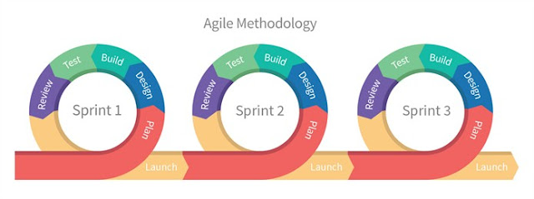

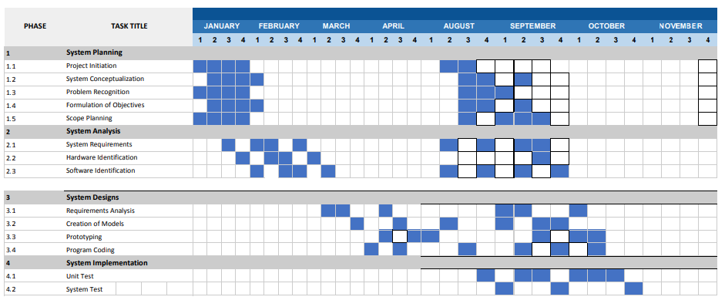

Figure 2: Gantt Chart of the System

DEFINITION OF TERMS

Collaborative Environment. It is an environment where two individual such as teacher and learner interact each other online, sharing ideas and collaborate each other.

Chat Box. It is included in the IDE or environment of the system; It is where both learner and teacher can interact by sending and receiving a message.

Live code editor. It is included in the IDE or environment of the system; It is the process wherein both learner and teacher enters’ a series of programming code and both of them can perceive the changes of code in real-time.

Web-based Application. It is where both learner and teacher will facilitate in doing and completing your task related to code. It is an application or environment where the collaboration occurs. It can be access through the appropriate web browser called Google Chrome.

Web conferencing. It is included in the IDE or environment of the system; It includes the navigation of web camera, microphone and audio where both teacher and learner can interact each other using video and audio of the computer.